QUIZ RESULTS
MODULE5: NONLINEAR AND DISTANCE-BASED DIMENSIONALITY REDUCTION

No. | Quiz title | Completion Status | Score | Coursera link
1 | Module5_1_Kernel PCA and MDS | Completed | 100% | Quiz 1
2 | Module5_1_Kernel PCA and MDS | Completed | 100% | Quiz 2

Module5_1_Kernel PCA and MDS
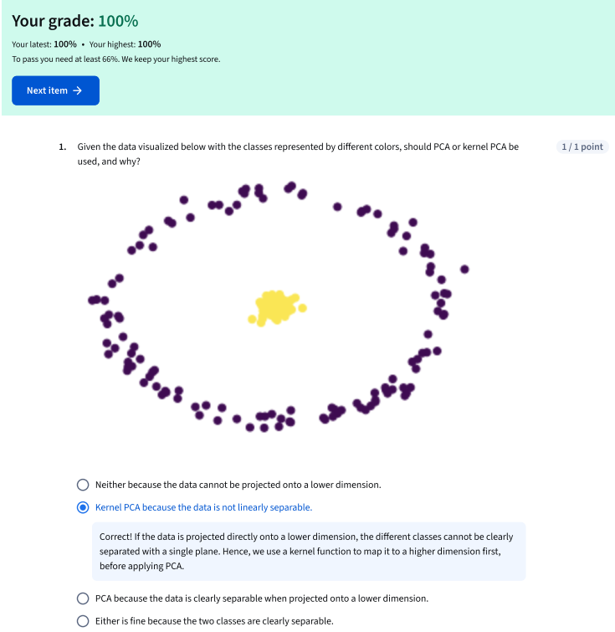
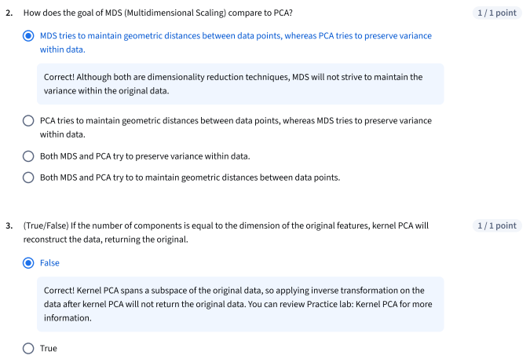

Module5_2_Module 5 Quiz
